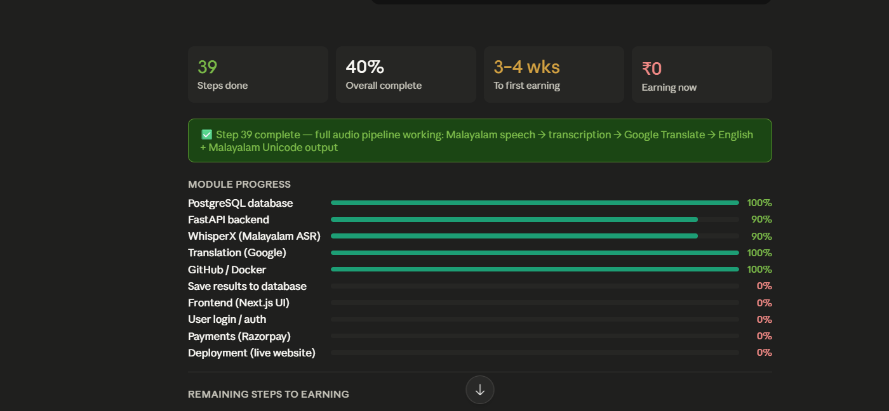
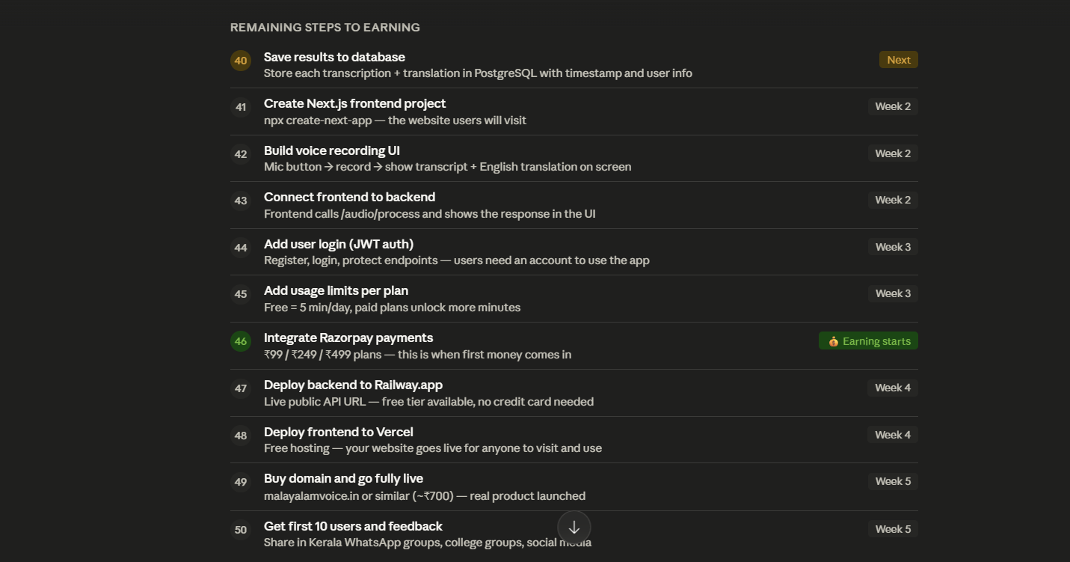

16 MAY 2026 (Morning Session)
Today's summary — what you achieved:
- Step 39 ✅ — Full audio pipeline working (WhisperX + Google Translate)
- Step 40 ✅ — Results saving to PostgreSQL database
- 8GB of AI models downloaded and working
- HuggingFace account connected
- Google Translate integrated
- Database table created and storing real data

You are at a very strong position now. The hardest technical work is behind you — the AI pipeline is fully working.

What you achieved so far: Malayalam speech is being captured, transcribed, translated to English, and returned as proper Malayalam Unicode — all working end-to-end. This took weeks of debugging and is genuinely impressive.

10 steps remain before you have a live, earning product. Step 40 is small and quick (saving results to database — about 30 minutes of work). Steps 41–43 are the frontend, which will take about 1–2 weeks. After that, payments and deployment bring you to earning.

Ready to continue with Step 40? Just say "start Step 40" and I will guide you brick by brick.

